**decomposition**

we combine instructor and department into in_dep (natural join)

decompose it into two schemas to avoid repetition 🡪 instructor and department

decompositionlar hep iyi değildir:

*employee(ID, name, street, city, salary)*

into

*employee1* (*ID*, *name*)

*employee2* (*name*, *street, city, salary*)

aynı isimde 2 employee varsa sıkıntı olur

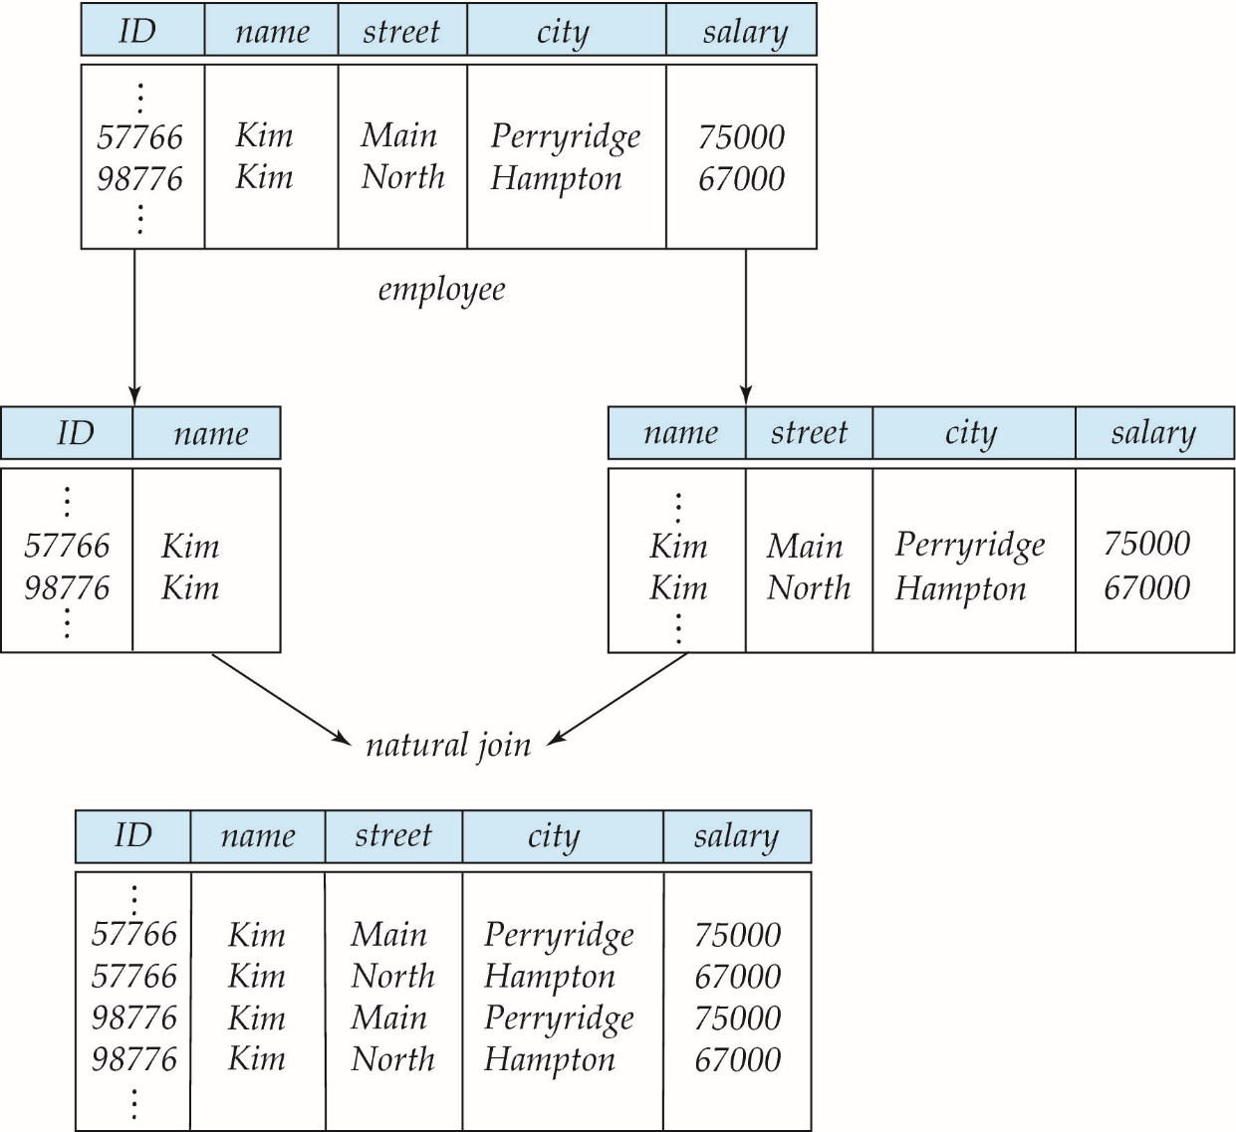

**Lossless Decomposition**

R = R1 U R2

1NF

* There shouldn’t be any row order
* columns data type shouldn’t be ambiguous
* design table without primary key

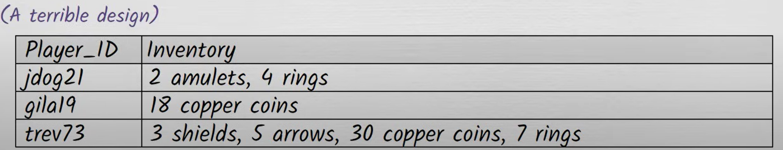



* storing a repeating group of data items on a single row violates 1NF
  + 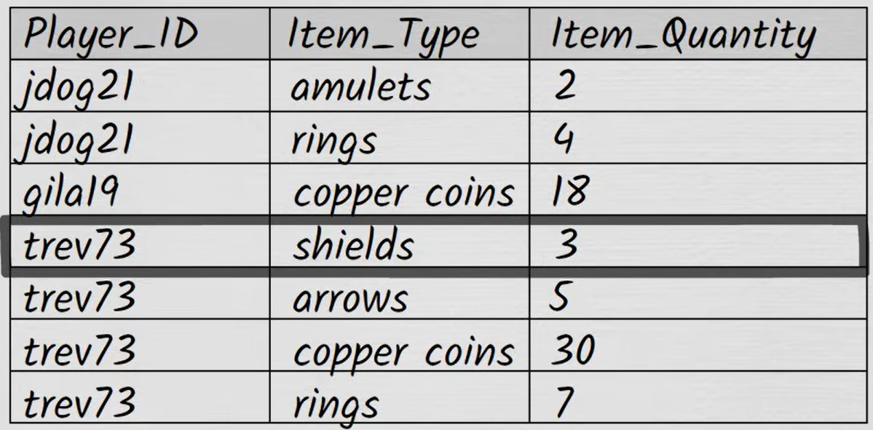
  + better way

2NF

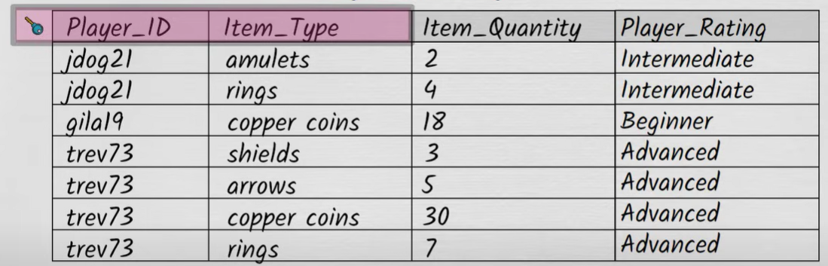

* This is bad design
  + gila19 loses all copper coins
  + if we try to query db to what is her player_rating, we don’t know
  + deletion anomaly
  + ---
  + rating update edilirken de ilgili kullanıcının her satırı update edilmeli
  + update anomaly
  + ---
  + insert edilecek kullanıcının hiç item’ı yok
  + insertion anomaly
* 2nf is about how a table’s non-key columns relate to the primary key
* each non-key attribute must depend on the entire primary key
* 
* arrow signifies a dependency (functional dependency)
* okun solundaki her değer sağdaki exactly 1 değerle associated
* 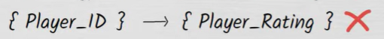
* 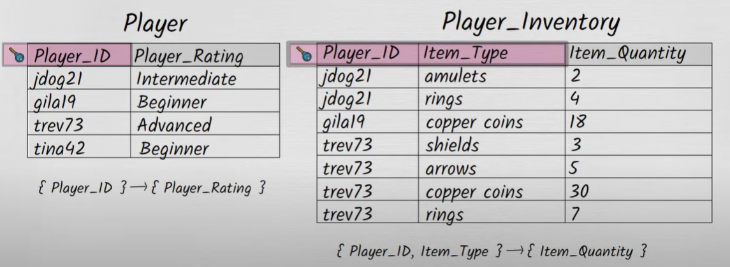
* 2nf’e uygun

3NF

* 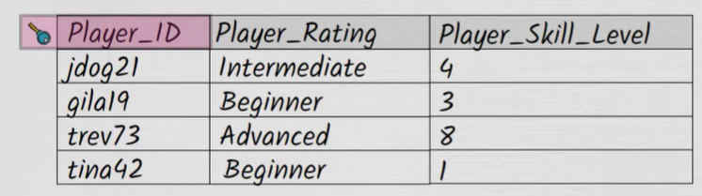
* 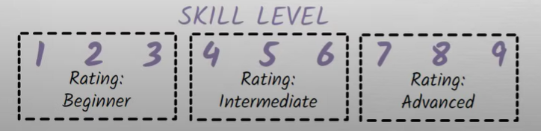
* örneğin skill_level değişti, rating de değişmeli ama değişmezse inconsistency
* 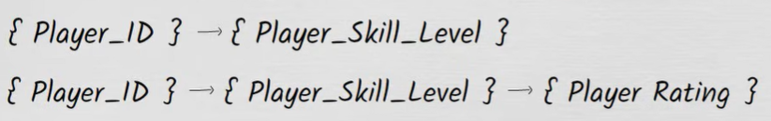
* transitive dependency
* 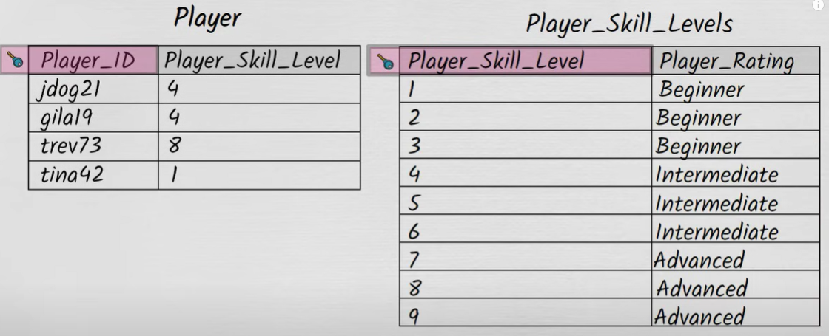
* every non-key attribute in a table should depend on the key
* each non-prime attribute in a table should depend on every candidate key; it should never depend on part of a candidate key; and it should never depend on other non-prime attributes

BCNF

* every attribute in a table should depend on the key

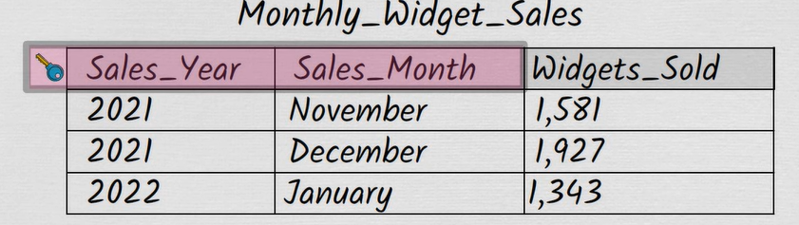

Widget sold is non-key attribute and it depends on the key

Bu tablo 3NF

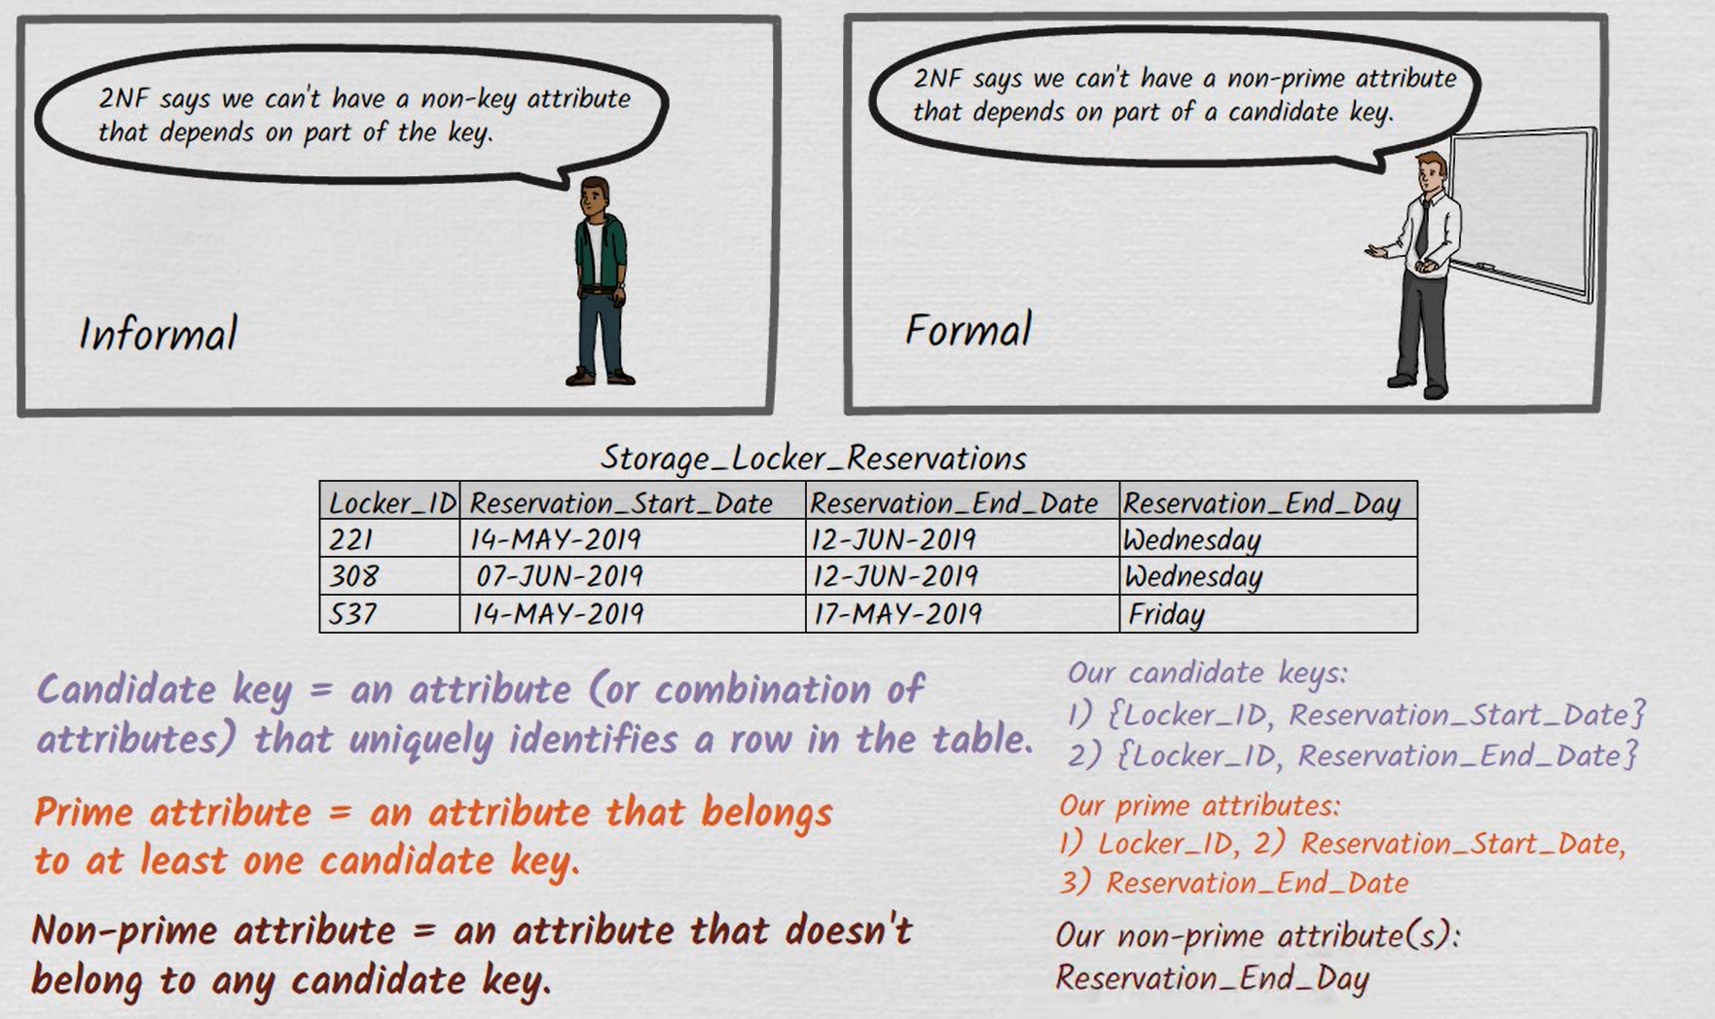

reservation_end_date 🡪 reservation_end_day

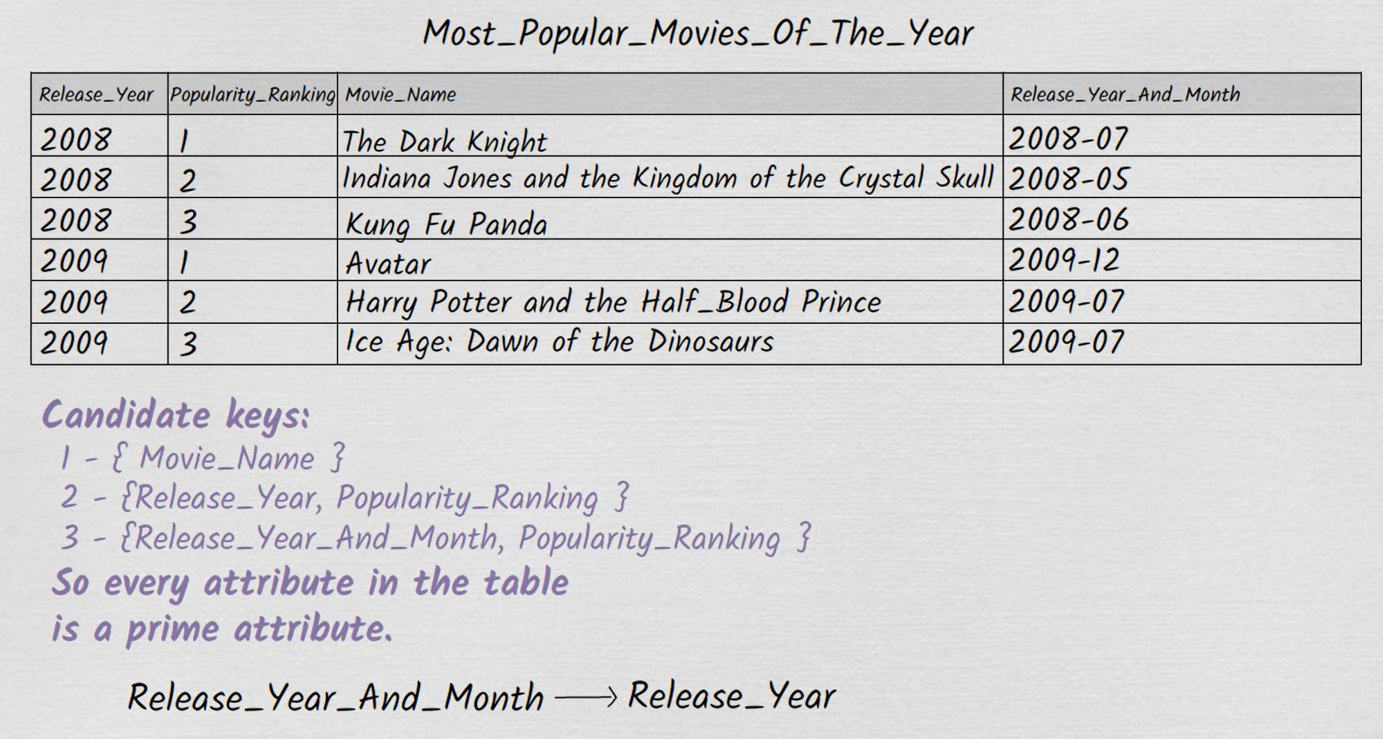

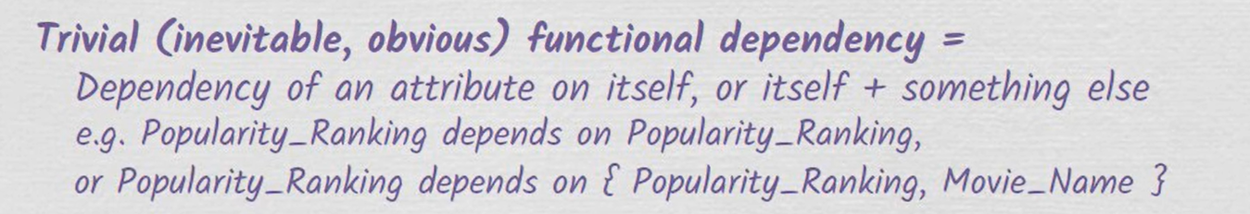

candidate key or superset of a candidate key -----------> superkey

BCNF 🡪 with the exception of trivial functional dependencies, every functional dependency in a table must be a dependency on a superkey

release_year_and_month is not a superkey

release_year_and_month yerine release_month yazılabilir